Development of an Elephant Hill (EH) IBD (Insect, Beetle, Douglas-fir) Control Treatment Strategy
Where:
EH Wildfire Boundary and 5 km external buffer – More specifically identified polygons with live mature leading Fdi types.
Objective:
- To protect and retain as much residual live Fdi structure in the EH wildfire boundary as possible for: mid-term timber supply, habitat, biodiversity, seed source for regenerating Fdi leading types
- Maximize targeted IBD control treatments where applicable to limit or reduce IBD population expansion while monitoring natural mortality factors to facilitate population control
How:
- Identify opportunities in the fire perimeter and in the identified buffer outside the fire perimeter – Overview fights and Identified polygons.
  - Polygon Id: 19M001 – polygon identified in 2019, M = DMH or K = DTR, 001, 002, 003 – consecutive polygons identified in the EH fire.
- Utilized Detailed and Overview flight data for IBD detection – where possible (2019 detailed Cariboo flight was unsuccessful in providing data, too many fire killed red trees)
- IBD Recci Survey – Data collection phase - Rank polygons for survey as follows:
  - Areas with high known pre-fire beetle populations
  - Areas of high hazard for IBD
  - Areas with developed access
  - Areas without known operability issues (Slope)
  - Address larger polygons first
  - Address polygons where multiple control tools can be successfully deployed i.e. funnel traps, trap trees and MCH
- Ranking Opportunities and Options and allocate units for treatments (Who is doing what where)
  - Units with any cutting of trees (trap trees, salvage, bait blocks) need to be allocated to a licensee with cutting authority
  - For Joint management of units figure out who is responsible for doing what (i.e. Licensee deals with traps trees, Ministry installs MCH for a push-pull treatment)
- Using the IBD Recci data develop detailed multi-year plans with contingencies for each high priority polygon - addressing as many of the polygons as time and resources allow – Utilizing knowledge of the Beetle life cycle and the following tools:
    - Lindgren Funnel Traps
    - Trap Trees
    - MCH
    - Small Scale Salvage (SSS)
    - BCTS – TSL’s
    - Major Licensee – Blanket Salvage Permits
    - Small Blocks with lures – These units allow for a longer planning cycle to ensure layout, Site Plan, Arch work and harvesting happens over a longer more controlled timeline. This is a bring the beetles to us verse chase the beetle’s strategy.
An effective plan will contain one or more (in combination) of the various treatment tools over a few years (1 to 3 beetle cycles).
- Plan Implementation
- Monitoring
Expectations:
Implementing the above control measures for IBD will hold or reduce IBD populations in critical areas where maximizing green tree retention is a critical goal.
Effective IBD control treatments sometimes require the sacrificing of some healthy live Fdi trees to control the population (trap trees and small blocks with lures).

Guiding Principles:
Don’t make things worse!
All treatment tools require maintenance and follow up action: periodic maintenance of funnel traps; timely removal of trap trees; salvage harvest on strict timeline.
If you are not 100% certain that you can pull off the planned treatment (budget, resources and time) you are best to do nothing. Many treatment tools require removing infested trees during the winter harvest season and an early breakup (road bans) can quickly turn a good plan into a disaster.
Debris piles with live brood need to be burned before March 31st, therefore waste and residue surveys need to be completed immediately after treatment.
The best beetle control strategies are proactive vs. reactive, getting in front of the beetles rather than chasing where they have been. We want to be the Wayne Gretzky’s of IBD pest management (Wayne always knew where the puck was going to be.)

Rules of Thumb
Large Fdi trees damaged by the fire will attract IBD
When the supply of fire damaged trees are depleted, IBD will attack healthy live trees
Well placed Trap Trees can hold up to 4 times the number of beetles that a standing live tree.

IBD Surveying Methodologies:
Because we have a large area to work in and limited resources our goal is to deploy our resources in the most effective and efficient way. To do this we need stand level information. We get this information from surveys. A coordinated survey approach is needed. We have identified over 18,000 ha in Fdi leading polygons inside the fire boundary.
- Different surveying methods and intensities are needed to achieve our objectives
  - Recci – strategy plan development
  - Detailed Stem Mapping – for single tree mark to cut salvage harvest
- Surveying can be expensive and time consuming so targeting priority areas quickly is critical
- For our process, the first assessment is a recci survey – this is the survey used to develop the landscape level plan which defines what resources are deployed where.

The IBD Recci Survey
It is important to keep your survey objective in mind when doing recci surveys and to gather only the information needed. We need this quick overview survey data to develop a strategic landscape level (EH Wildfire) IBD plan for deployment of tactics and treatments. Our objective is to locate the polygons that:
- Have a susceptible type:
  - Leading Fdi
  - > 30 cm in diameter
  - > 60 years old
  - Larger polygons would rate higher for attention than smaller polygons
- Have access for harvesting and hauling equipment
- Have current beetle populations – not always a pre-requisite
- Preference for polygons outside of Constrained areas – OGMA’s, MDWR, Visual’s, WTRA, FN features (known Arch / CH), WHA’s – treatment options may be limited in these areas.
To complete an IBD recci report you need the following skill set:
- Tree species identification
- Basic Ecosystem classification knowledge
- Knowledge of Forest Harvesting and Transportation Systems
- Knowledge of IDB life cycle
- Ability to identify IBD attack, both current (with live beetles) and non- current (without live beetles) attack
- Ability to assess level of IBD attack (nil, low, medium, high or percent of trees attacked)
- Ability to identify other forest health factors (DRA)
- Knowledge of the IBD management tools and how to deploy them
- Basic mensuration skills, measurements of trees – height, diameter, volume
- Navigation and mapping skills – ipads with avenza
- Inhouse or Contract GIS / Mapping services
A Recci survey is a preliminary survey which collects the information to develop priorities and action plans for each polygon. Recci surveys do not have any stem mapping or painting.
Proposed Recci Survey Methodology
Start with assigned polygon. In this case it is Unit 19M030 = 253.7 ha
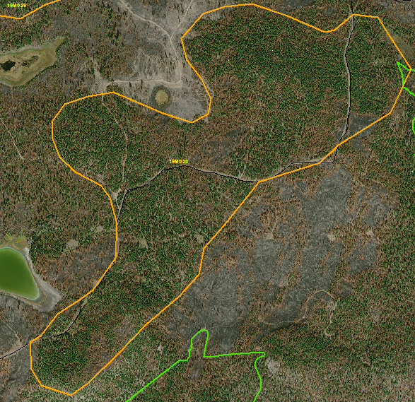
Locate a POC and have the mapping department install a 100 meter survey grid. This map is saved as “Recci Map 19M030” a geo-referenced PDF map and is uploaded to the ipad.
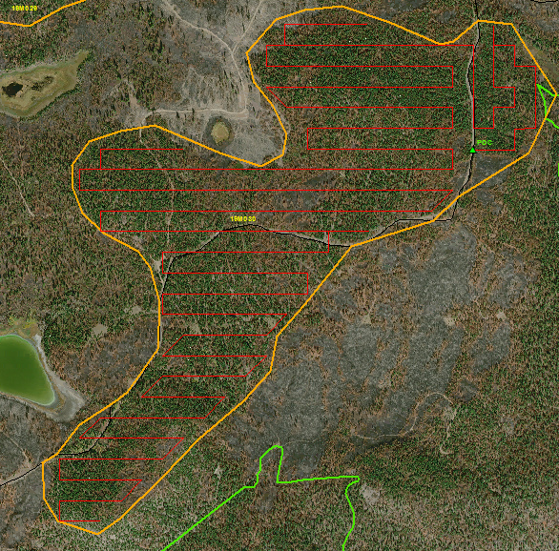
The recci survey crew will follow the grid lines and locate and count the number of current attack IBD trees on both sides of the survey line, the survey sample area is 10 meters wide on either side of the survey line. The survey lines can be divided into individual lines or groups of lines for data collection purposes. You can label your line segments as you go by dropping a pin with a label. You should also make notes on your pdf map as you completed the survey, showing heavy concentrations. Remember we are not stem mapping current attacks just keeping notes to help develop a plan for future treatments.
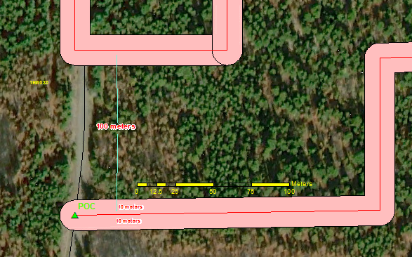
Close-up view of POC and start of survey area, note 100 meters between survey lines. The pink shows the survey area of 10 meters on both sides of the survey line. Using a combination of tablet and compass traverse the area and use a field card to tally number of current attacked trees.

This is what the whole survey area looks like.
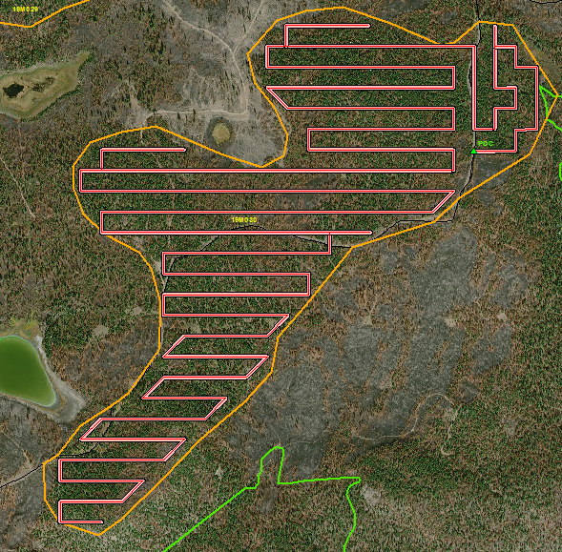

Summarizing the Survey Data
Unit 19M030 = 253.7 ha
Number of current attack trees counted in the survey area 2,873 trees.
Length of Survey Line: 24,298 meters
Area surveyed: 48.7 ha
48.7 ha
253.7 ha = 0.192 X 100 = 19.2% sampling intensity
And a little basic algebra…
48.7 ha 2,873 current attacked trees for the sample
253.7 ha = X current attacked trees for the sample polygon

X = 253.7 ha * 2,873 beetles / 48.7 ha = 14,967 current attacked trees in the polygon.

On average there is 14,967 current attack trees / 253.7 ha = 59 current attacked trees per ha

Review attached report for plan content.
David Majcher 12-Sep-19

